Requirements Specification

# **Project Name**

Applied Language Research

**Prepared by**

Applied Language Team

# **Date**

4 October 2020



# **1.** **Introduction**

The Applied Language Team has prepared this document to provide a detailed outline of the Applied Language Research project requirements. This document includes a thorough look into:

* The system’s different user groups, their priorities, and individual tasks that they will be performing through this project.
* Where, when, and how the system will be used.
* The feedback gathered from the various user groups regarding the existing system and the extensions to the system that are being created.
* The project's specific functional requirements and specifications, along with any non-functional constraints, software, and hardware requirements.

# **2.** **User Overview**

The users of the Applied Language Research project can be divided amongst five different user types, each with separate tasks to perform and concerns needing to be addressed in the final product. These five user groups are as follows:

**Researchers:** Researchers will utilize the system to access all of the data being generated by other user groups. This includes the rendering of Microsoft Excel reports revealing the effectiveness in learner pronunciation of specific words and the overall pronunciation ratings across all words to reveal trends. Researchers will also be able to upload audio segments to the service to allow for previously gathered audio data to be ingested into the system.

**Native Speakers:** Native speakers are the user group tasked with listening to and critiquing the audio pronunciations being generated by the language learners. This information should then be presented to the student to receive direct feedback, the teachers to gauge their students' performance, and the researchers so they can get a broad overview of the data.

**Language Learners:** The lowest level users of our system are the language learners, who will use the system for a few simple tasks. This includes recording/uploading audio, sharing audio, and viewing past submission comments/ratings.

**Language Teachers:** Teachers will be creating and managing classes of learners in the software to review student progress towards learning goals. Using the system, they will be able to view the Native speakers' critiques on their students' pronunciations.

**Administrators:** The administrators are the highest user group level, whose primary function is to manage the web service's day-to-day running. Their responsibilities include maintaining the server's database, operating the web server and host machine, and addressing any concerns raised by the other user groups.

# **3.** **Hierarchy Chart of Users**

The hierarchy chart begins with Dr. Mizuki Miyashita as she is the progenitor of this project/website. Researchers are one step below Dr. Miyashita but will functionally be using the website in the same way. Learners, Native speakers, and teachers branch from researchers because they will learn of the website most likely from researchers. Learners, Native speakers, and teachers each have their own blocks because they will each use the website in a different way and for different results.

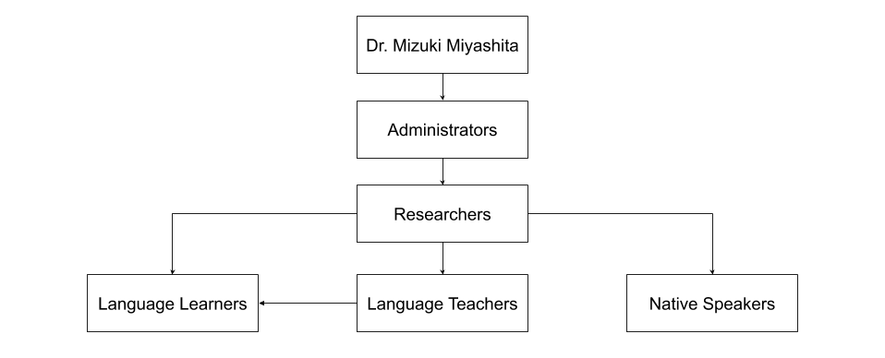

# **4.** **User Groups**

The table below lists the types of users as well as the number of users of that type and a detailed description for each user type.

|  |  |  |
| --- | --- | --- |
| User Type | Number | Description |
| Researcher | 1-5 | Researchers are gathering and using all of the data collected. As well as editing and reviewing audio. Researchers have advanced security privileges that allow them to view and edit the data of language learners and Native language speakers. Researchers will use features to view and edit data from language learners and Native language speakers. Researchers may not have extensive knowledge of computer systems. Researchers may use the system several times a day mainly to view data to then later analyze. |
| Native Language Speaker | 5 | Native language speakers are fluent speakers of the Blackfoot language who will be using the tool to listen to and rate audio recordings of Blackfoot words. A Native speaker's access level would be that of a guest user as the research does not require non-repudiation on their part. Native language speakers will also not be using the system more than several times a week per speaker. |
| Language Learner | 30 per class | Language learners are students who are learning the Blackfoot language. They will be using the tool to record and upload audio recordings of spoken Blackfoot words. A language learner's access level would be that of a regular user, requiring them to log in to the system and keep track of their recordings. |
| Language Teacher | 1-3 per class | Language teachers are teachers of the language learners and need to view the students’ rating data and respond to and rate the students’ submissions in their class. Language teachers will access the system up to 20 times a day to check their class’s data. Language teachers may not have extensive knowledge of computer systems. A language teacher's access level would allow them to view and respond to all of the language learners in their class. |
| Administrator | 2 | Administrators will maintain the service’s database and troubleshoot any bugs/concerns that come up after the product’s deployment. Administrators will also manage users of the system, adding and removing users as necessary. Administrators will have the highest access level. |

# **5.** **User Feedback**

The team’s preference for collecting feedback from language learners and Native speakers was an online survey. We determined that this was a feasible solution to collect feedback while staying safe from COVID-19. In our survey, we asked questions ranging from user experience with technology to scenarios using images of the website, asking what the user would do. No personal information was collected in the surveys.

Throughout this process, the team received thirty-four responses from students and one response from a Native speaker. The responses from the survey informed the team on which devices are most utilized when browsing the web, how well users perceived the presentation of the existing website, and identified some misleading and confusing UI elements. The team can use this feedback to design a better user interface that requires less of a learning curve to use and is more productive for all user groups.

From the feedback received, the team has learned that students almost evenly and exclusively utilize mobile and laptop devices when browsing the web; from this information, the team learned that the user interface will need to accommodate smaller screen sizes. The feedback on the existing user login page revealed that users, when presented with many options on a page, will perform a variety of different actions; this lets us know that we should build the website with simplification in mind. Overall, the feedback from the users on the appearance of certain pages was mixed: 72.7% of users on the login page, 36.4% of users on the registration page, 84.9% of users on the home page, and 39.4% of users on the upload audio page found those pages to be appealing. When having to fill out fields on the upload audio page, some of the fields were not easily understood by users; this informs us that fields may need an accompanying description for clarification.

See Appendix A - Language Student Survey for a copy of the language student survey used.

See Appendix B - Native Speaker Survey for a copy of the Native language speaker survey used.

See Appendix E - Survey Results for the results from the surveys.

# **6.** **Functional Requirements**

Functional requirements are requirements that define basic system behavior. Below is a table of the functional requirements for the project. The requirements are ordered by the requirement group and priority level. Requirements which have not been implemented by previous teams are highlighted in red. For an explanation of the letters and numbers in the left-most column, see Appendix D - Key to Requirements Labeling.

|  |  |
| --- | --- |
| **(R) Researchers** | |
| R.H.1 | Researchers should be able to upload audio clips of Blackfoot words being spoken. |
| R.H.5 | Researchers should be able to provide a unique link to a Native language speaker that allows the speaker to rate an audio clip without logging in to the website. This unique link is meant to be used by only one Native language speaker. |
| R.H.6 | Researchers should be able to register new accounts with their first name, last name, email address, and password. |
| R.H.7 | Researchers should be able to login to their researcher account using their email address and their password. |
| R.H.8 | Researchers should be able to confirm their account after registering using a confirmation code and link sent to their email account. |
| R.H.9 | Researchers should be sent a verification email when a Native Language Speaker completes a rating. |
| R.M.1 | Researchers should be able to create a single link for multiple audio recordings. |
| R.M.2 | Researchers should be able to gather demographic data from new learners including: age, gender, and native language. |
| R.M.3 | Researchers should be able upload and display an IRB consent form for new learners. |
| R.M.4 | Researchers should be able to include demographic data for audio recordings that they are uploading. |
| R.L.1 | Researchers should be able to launch the PRAAT software application from the site or use integrated PRAAT mechanics on the site. |
| R.L.2 | Researchers should be able to import the output of a PRAAT session into the system’s database. |
| R.L.3 | Researchers should be able to limit the displayed audio data to a range of dates, and set numbers of words and/or learners. |
| R.L.4 | Researchers should be able to trim large audio files into smaller audio files by selecting a portion of the large audio file and saving that portion as a smaller file. |
| R.L.5 | Researchers should be able to search or filter data by the word and language spoken in the audio recordings. |
| R.L.6 | Researchers should be able to view graphs showing the average rating for a particular: spoken word, student, and language being spoken. |
| R.L.7 | Researchers should be able to upload previously gathered data including excel sheets, audio files, acoustic measurements, and word ratings. |
| R.L.8 | Researchers should be able to download data on acoustic measurements and word ratings into a comma-separated spreadsheet file. |
| **(N) Native Language Speakers** | |
| N.H.1 | Native language speakers should be able to rate audio files on a scale of 1 to 5 regarding the accuracy and quality of audio pronunciations. |
| N.H.2 | Native language speakers should be able to access and rate an audio file without a login. |
| N.M.1 | Native language speakers should be able to leave written comments on a particular student’s audio recording. |
| N.M.2 | Native language speakers should be able to rate multiple audio files at once from a single unique link. |
| N.L.1 | Native language speakers should be able to leave audio comments on a particular student’s audio recording. |
| N.L.2 | Native language speakers should be able to record prompts for teachers to use in assignments. |
| **(T) Language Teachers** | |
| T.L.1 | Language Teachersshould be able to establish classes and approve the joining of students’ into those classes. |
| T.L.2 | Language Teachers should be able to access the ratings of individual students in their classes. |
| T.L.3 | Language Teachersshould be able to create assignments for students using recorded prompts or text. |
| T.L.4 | Language Teachersshould be able to rate students’ audio recordings in terms of the pronunciation’s correctness. |
| T.L.5 | Language Teachersshould be able to create a recording of themselves telling a story in a specific language to which students may listen. |
| T.L.6 | Language Teachersshould be able to register new accounts with their first name, last name, email address, and password. |
| T.L.7 | Language Teachersshould be able to login to their teacher account using their email address and their password. |
| T.L.8 | Language Teachersshould be able to confirm their account after registering using a confirmation code and link sent to their email account. |
| **(L) Language Learners** | |
| L.H.1 | Language Learners should be able to record and upload audio clips of spoken words. |
| L.H.2 | Language Learners should be able to provide a text description to accompany their recorded audio. |
| L.H.3 | Language Learners should be able to view the ratings and feedback of only their audio clips. |
| L.H.4 | Language Learners should be able to register new accounts with their first name, last name, email address, and password. |
| L.H.5 | Language Learners should be able to login to their student account using their email address and their password. |
| L.H.6 | Language Learners should be able to confirm their account after registering using a confirmation code and link sent to their email account. |
| L.M.1 | Language Learners should be able to listen to their pronunciations in their recorded audio files. |
| L.L.1 | Language Learners should be able to listen to a Native language speaker’s pronunciation of a given word. |
| L.L.2 | Language Learners should be able to view any additional written comments associated with their particular audio recordings. |
| L.L.3 | Language Learners should be able to enter words from multiple languages. |
| L.L.4 | Language Learners should be able to join their Language Teachers classes. |
| L.L.5 | Language Learners should be able to trim large audio files into smaller audio files by selecting a portion of the large audio file and saving that portion as a smaller file. |
| **(A) Administrators** | |
| A.H.1 | Administrators should be able to add and remove users from the other user groups. |
| A.H.2 | Administrators should be able to backup and restore all of the audio files stored on the web server, and data stored in the database. |
| A.H.3 | Administrators should be able to perform all functions that any other user type can perform (researchers, language learners, Native language speakers, and teachers). |
| A.M.1 | Administrators should be able to approve the registration of researcher and teacher accounts. |

# 7. Non-functional Requirements

Non-functional requirements refer to the functions necessary to support the system and the performance guarantees of the system. The table below is sectioned by the requirement group and then the priority level. For an explanation of the letters and numbers in the left-most column, see Appendix D - Key to Requirements Labeling.

|  |  |
| --- | --- |
| **(NF) Non-Functional** | |
| NF.H.1 | The system should be able to support the Blackfoot alphabet. |
| NF.H.2 | The system should present the same layout between all desktop view devices, as well as the same layout between all mobile view devices. |
| NF.H.3 | The system should support major functionalities such as uploading audio, creating accounts, logging in, rating audio, and researchers’ ability to acquire rating data, without crashing. |
| NF.H.4 | The system should handle any existing errors within the background of the website where the users will not need to be concerned with them. |
| NF.H.5 | The system should be free of any data vulnerabilities that would allow user data to be exposed. |
| NF.M.1 | The system should comply with all University of Montana “Disability Services for Students” requirements and policies. |
| NF.M.2 | The system should prepare audio files for raters within 1 second of requesting the data. |
| NF.M.3 | The system should be able to send a download of ratings in less than 2 minutes on a web connection of 1 Mb/s or higher. |

**8.** **Hardware Requirements**

Hardware requirements for the project are outlined in the table below and ordered by priority level. For an explanation of the letters and numbers in the left-most column, see Appendix D - Key to Requirements Labeling.

|  |  |
| --- | --- |
| **(HW) Hardware** | |
| HW.H.1 | The web server should be able to support up to 5 gigabytes of audio files. |
| HW.H.2 | The web server should be able to support 40 simultaneous users. |
| HW.H.3 | The web server should backup the server data in an automatic weekly process. |
| HW.M.1 | The web server should have a 99.9% server up-time, with the remaining 0.1% being for reboots and updates. |

# 

# **9.** Software Requirements

Software requirements for the project are outlined in the table below and are ordered by priority. Note: this section only contains high priority requirements. For an explanation of the letters and numbers in the left-most column, see Appendix D - Key to Requirements Labeling.

|  |  |
| --- | --- |
| **(SW) Software** | |
| SW.H.1 | The website should be accessible from Microsoft Windows (XP and later) and macOS (X and later) operating systems. |
| SW.H.2 | The website should be accessible on Google Chrome, Microsoft Edge, Microsoft Internet Explorer, Mozilla Firefox, Safari, and Opera web browsers. |
| SW.H.3 | The website will use the Django web framework. |
| SW.H.4 | The website will use SQLite as the back-end database. |
| SW.H.5 | The website will display pages using the latest CSS alongside HTML5. |

# 10. Database Requirements

|  |  |
| --- | --- |
| **(D) Database** | |
| D.H.1 | The database should be able to store the server’s file location of audio files, the audio’s length, language, upload date, and associate the audio with the individual who uploaded it. |
| D.H.2 | The database should be able to store all of the ratings each audio file has received and any additional written feedback provided by the rater. |
| D.H.3 | The database should store a user’s first and last name, user type, registration date, and email. |
| D.M.1 | The database should store an admin log that records all user actions, the user performing the action, and the time the action occurred. |
| D.L.1 | The database should store each class’s start and end date, any associated teachers and students, and the language being taught in that . |

# 

# 

# 

# Appendix A - Language Student Survey

# 

# Appendix B - Native Speaker Survey

# 

# 

# Appendix C - Ethics Course Certificates

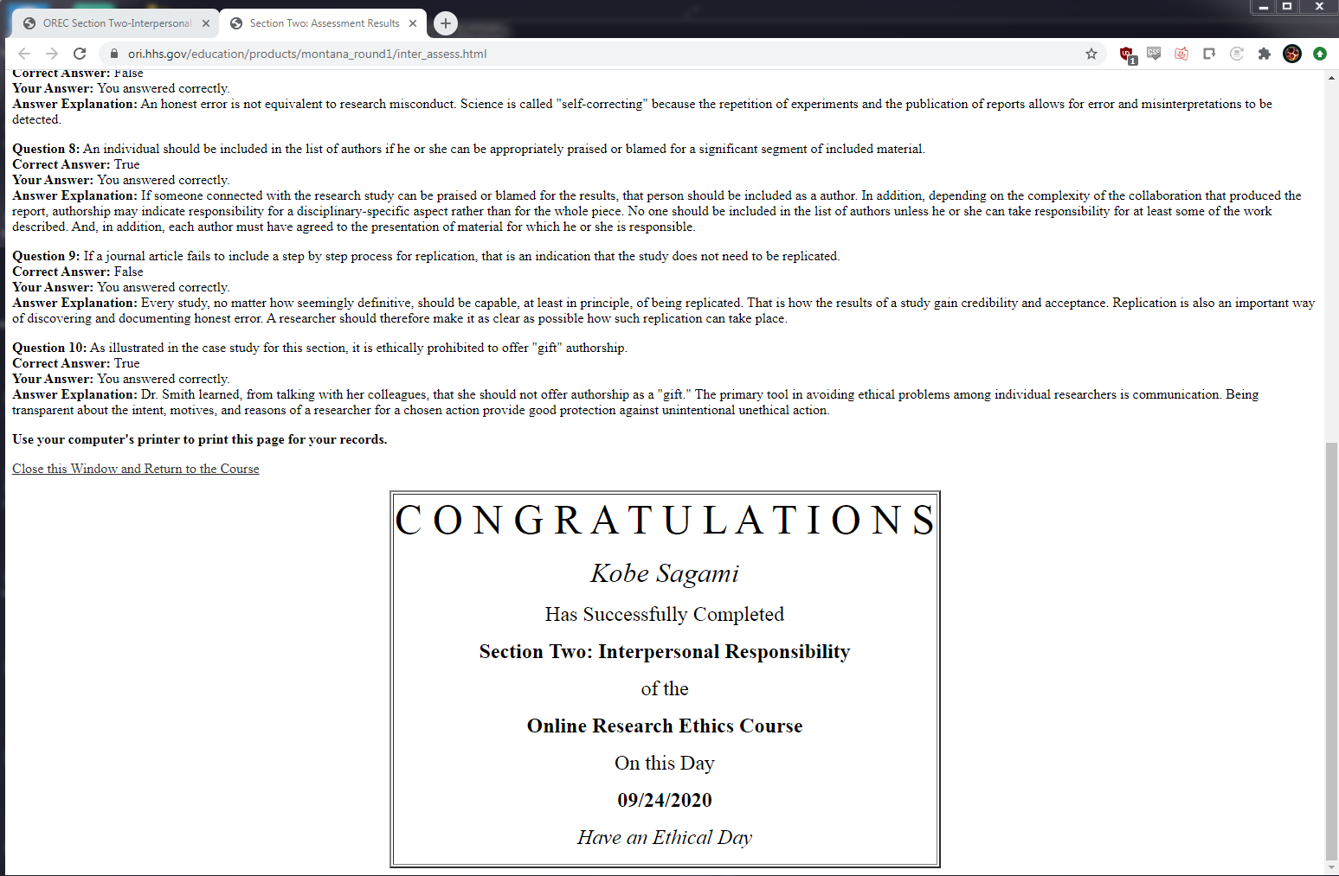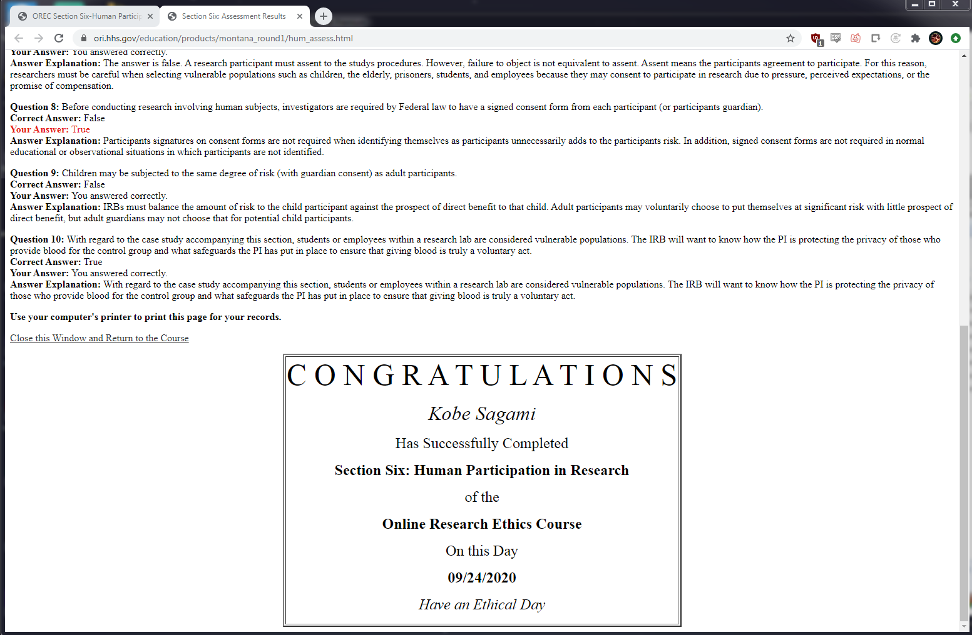



# Appendix D - Key to Requirements Labeling

User or Function Code . Priority . Requirement Number

|  |  |  |
| --- | --- | --- |
| User or Function Code | Priority Level | Requirement Number |
| A: Administrators | H: High priority (necessary for basic program functionality) | #: Number for ordering |
| D: Database | L: Low priority (implemented after all high and medium priority requirements) |  |
| HW: Hardware | M: Medium priority (not necessary for basic program functionality) |  |
| L: Language learners |  |  |
| N: Native language speakers |  |  |
| NF: Non-functional |  |  |
| R: Researchers |  |  |
| SW: Software |  |  |
| T: Teachers |  |  |

# Appendix E - Survey Results

